Electronic waste (e-waste) now makes up five percent of all municipal solid waste worldwide, that is nearly the same amount as all plastic packaging, but it is much more hazardous. Not only developed countries generate e-waste; Asia discards an estimated 12 million tons each year.
E-waste is now the fastest growing component of the municipal solid waste stream because people are upgrading their mobile phones, computers, televisions, audio equipment and printers more frequently than ever before also some of the problem is that people are replacing their computers really frequently

- The nation now dumps between 300 million and 400 million electronic items per year, and less than 20% of that e-waste is recycled
- Electronic items that are considered to be hazardous include, but are not limited to:
- • Televisions and computer monitors that contain cathode ray tubes
- • LCD desktop monitors
- • Laptop computers with LCD displays
- • LCD televisions
- • Plasma televisions
- • Portable DVD players with LCD screens.
- E-waste legislation in the United States is currently stalled at the state level. Just 24 states have passed or proposed take-back laws. However, as of January 1, 2011, covered electronics are completely banned in West Virginia.
- Large amounts of e-waste have been sent to countries such as China, India and Kenya, where lower environmental standards and working conditions make processing e-waste more profitable. Around 80 % of the e-waste in the U.S. is exported to Asia.
8. The European Union banned e-waste from landfills in the 1990s, and current laws hold manufacturers responsible for e-waste disposal.
Cathode ray tubes in older TVs and computers typically contain about 4 lbs. of lead and sometimes as much as 7 lbs.
11. Flat panel computer monitors and notebooks often contain small amounts of mercury in the bulbs used to light them.
12. About 50 million cell phones are replaced worldwide a month and only 10% are recycled. If we recycled just a million cell phones, it would reduce greenhouse gas emissions equal to taking 1,368 cars off the road for a year
13. it’s energy efficient to rebuild old computers, but only about 2% of PCs ever find their way to a second user.
14. Because computer processing power doubles roughly every two years, many old computers are being abandoned. Only 15% recycle their computers, which means the other 85% end up in landfills
15. E-waste represents 2% of America's trash in landfills, but it equals 70% of overall toxic waste. The extreme amount of lead in electronics alone causes damage in the central and peripheral nervous systems, the blood and the kidneys.

http://www.dosomething.org

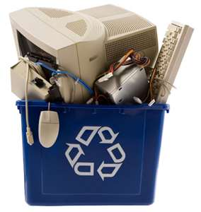

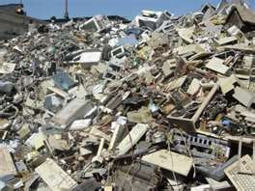

http://www.youtube.com

